Section One: Radioisotopes in Medicine:
- What are radioisotopes:
Radioisotopes are radioactive isotopes of an element. Different isotopes of the same element have the same number of protons in their atomic nuclei but differing numbers of neutrons. They can also be defined as atoms that contain an unstable combination of neutrons and protons.

- What occurs when a radioisotope decays?
When a radioisotope decays it emits radiation to achieve a stable state. The emissions from an unstable atom's nucleus, as it decays, can be in the form of alpha, beta, or gamma radiation. It then changes/ forms into another isotope. This isotope can either be the same or a different element and this is called Transmutation.

- How can radioisotopes be used in medicine?
There are two main using for radioisotopes in medicine. Both are to help with cancer.

Diagnosis: The isotope is administered, in numerous types of ways. The body naturally distributes different elements to different organs, so different isotopes are chosen for different parts of the body. It is then located in the body using normally a gamma-ray scanner. The decay product can be located, and the intensity measured. The amount of isotope taken up by the body can then give information as to the extent of the medical problem and if there is an unusual pattern on the scan it indicates a possible cancerous tumour.
An example of this is Iodine, which is sent to the thyroid gland by the liver, which allows us to detect thyroid cancer.

Treatment: Rapidly dividing cells are particularly sensitive to damage by radiation. External irradiation can be carried out using a gamma beam from a radioactive cobalt-60 source, this beam is then targeted at the area of the body with the cancer cells. This process can either control the growth of or fully eliminate the cancerous cells.
Another method is with internal radiotherapy. This is done by administering or planting a small radiation source, usually a gamma or beta emitter, in the target area. They are produced in wire form and are introduced through a catheter to the target area. After administering the correct dose, the implant wire is removed to shielded storage. This brachytherapy procedure gives less overall radiation to the body and is more localised to the target tumour, it also is more cost efficient.
An example of this is Iodine-131 also for the treatment of thyroid cancer.

- Discuss some of the risks associated with using radioisotopes in medicine
The largest issue with using radioisotopes in medicine is that it has a negative impact on the patient’s health. Tissues are damaged, which can lead to skin burns, nausea, diseases such as: lung cancer and even leukemia. The treatment also causes there to be a low count of blood cells (white blood cells, red blood cells, platelets). This causes the patients immunity and resistance to decrease dramatically. If the radioisotopes are used in an excessive amount can cause genetic mutations. Another risk is that they can denature and disrupt the process of protein synthesis, this can lead to the malfunctioning of an enzyme or a protein.

- Explain some other uses of radioisotopes.
Radioisotopes are used in many other industries and in a variety of ways. One of which is for quality detection. They are used for measuring the thickness of metal or plastic sheets; their precise thickness is indicated by the strength of the radiations that penetrate the material being inspected. This can see if the metal is the right thickness and if there are any defects. Another significant applications include the use of radioactive isotopes as compact sources of electrical power—e.g., plutonium-238 in spacecraft. In such cases, the heat produced in the decay of the radioactive isotope is converted into electricity by means of thermoelectric junction circuits or related devices. Another main use of radioisotopes especially in Australia is in the mining industry. In blasts furnaces, a metallurgical furnace used for smelting to produce industrial metals. It regulates the level of the filling of the blast-furnace based on the absorption of gamma rays from radioisotopes to detectors. It can also used to locate and quantify mineral deposits, to map geological contours using test wells and mine bores, and to determine the presence of hydrocarbons.
A common use in the household is in smoke detectors. Smoke detectors contain minute amounts of Americium-241 a transuranic element with an extremely useful property - its half-life. This produces alpha particles at a rate which creates an easily monitored steady voltage in the air between a pair of electrodes enclosed within an inexpensive plastic housing equipped with a simple circuit. When the voltage changes significantly, it triggers an audible alarm. The main cause of such a voltage change is variation in the composition of air - smoke being one probable cause. This is why modern smoke detectors may also register steam, dust, hair spray and other household aerosol packs.

Even Modern watches and clocks sometimes use a small quantity of hydrogen-3 or promethium-147 isotopes as a source of light. Older watches and clocks used radium-226 as a source of light, hence those dials that light up in the dark. They were originally designed for pilots flying at night during World War II.
Another significant applications include the use of radioactive isotopes as compact sources of electrical power—e.g., plutonium-238 in spacecraft. In such cases, the heat produced in the decay of the radioactive isotope is converted into electricity by means of thermoelectric junction circuits or related devices.
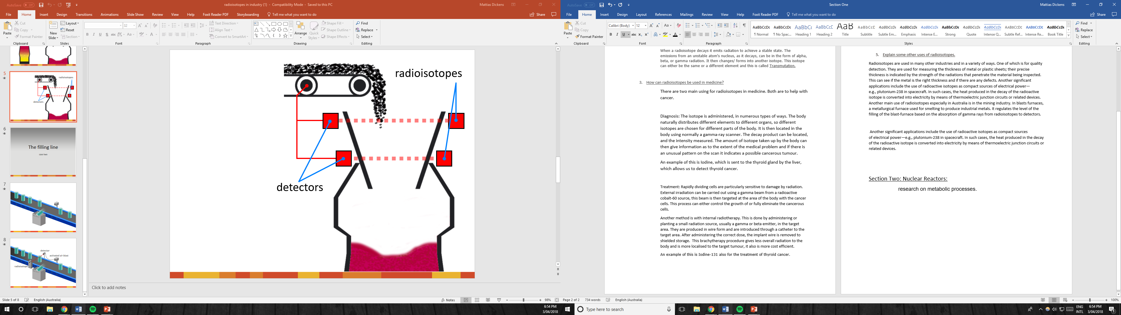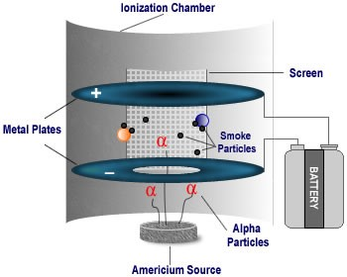

- Do You think the person who wrote this article is biased towards using radioisotopes or presents a neutral standpoint? Explain
I believe that this author of this article is quite neutral however there is a bit of bias towards using radioisotopes. Throughout the passage he mostly uses data such as “construction began on 1 February 1943” or “in 1948 [Clinton Laboratories] made more than 1000 shipments of radioisotopes. However, he never mentions or alludes to any negative effects of using radioisotopes in anyway. There aren’t any figures showing health issues, nothing. He also only glances over the bomb dropped in Nagasaki and the Manhattan Project and their effects. There isn’t any more bias towards radioisotope but instead mostly to the ORNL. His small biasness towards radioisotopes is quite acceptable due to his job, manager of the National Historic Chemical Landmarks Program at the American Chemical Society, and due to this speech focusing more on the ORNL.

Section Two: Nuclear Reactors:
- Explain how a nuclear reactor works. Describe the main parts.

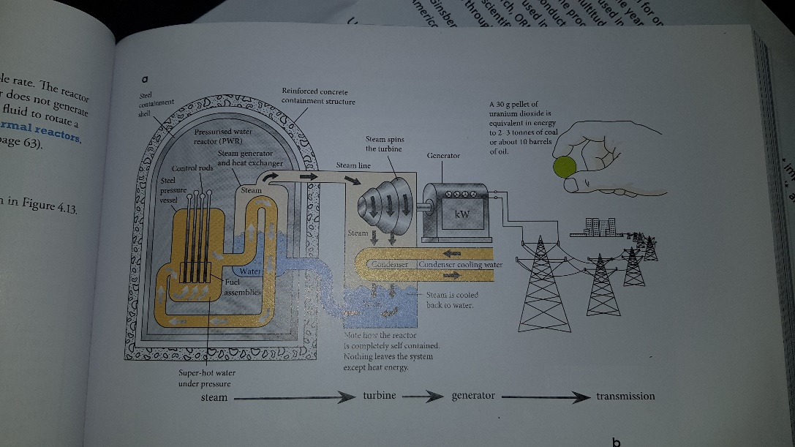

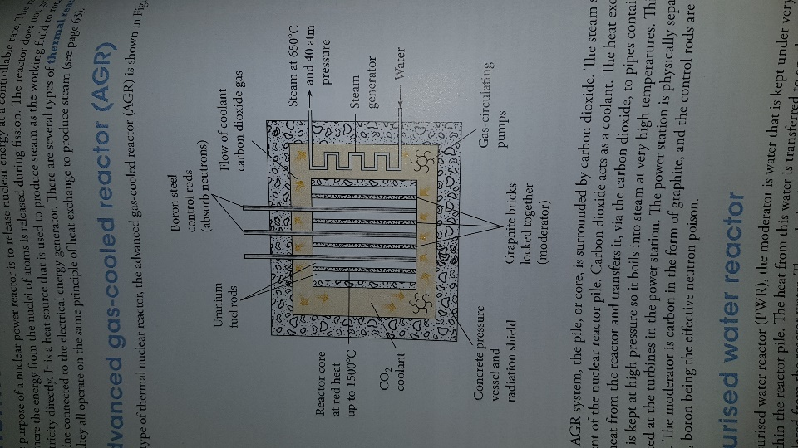
Advanced gas-cooled reactor
Carbon dioxide surrounds the core. The steam system is independent of the nuclear of the nuclear reactor pile. The carbon dioxide is used as the coolant for the rector. The heat exchange takes the heat from the reactor and transfer it, via the carbon dioxide, to pipes containing water. The water is kept at high pressure, so it boils into steam at very high temperatures. This steam is then directed at the turbines in the power station. The power station is physically separated from the reactor. The moderator is carbon in the form of graphite, and the control rods are made from boron steel, due to boron being the effective neutron poison.
** Pressurised water reactor is practically the same however the moderator is water.

Fuel rods: Usually 1-4% enriched uranium-235 is used as the nuclear fuel, which is in an airtight container.

Control rods: To control the chain reaction, some neutrons must be absorbed. This is done by means of control rods that are inserted in the reactor. These rods are made up of substances that are readily absorb neutrons (Neutron poisons), such as cadmium or boron Steel

Moderator: It is used to slow down the high energy, fast moving neutrons produced by the splitting of the uranium atom to continuously cause fission in uranium-235. It must have a low mass number, readily game kinetic energy from collisions with neutrons, and be a weak absorber of neutrons.

- Many countries use nuclear reactors to produce energy. What are the main benefits of nuclear energy?
There are many benefits to using nuclear reactors to produce energy. Unlike a coal-powered power plant, using nuclear reactors emits no greenhouse gases and this is even including the mining, enrichment, construction, and waste management.
Also, nuclear energy is very reliable in terms of that they can be operated and produce power over 90% of the time and most nuclear reactors are designed to operate for man than 40 years, with the capabilities of lasting an additional 20 years.
Another advantage for the public is that the cost of nuclear power is very stable and competitive, while other types of power prices can fluctuate depending on the markets of coal and oil.
Also, the run cost in very cheap, this is including an in fluxing price of uranium, which is normally very cheap.
Additionally, nuclear energy is very compact compared to system such as wind turbines which take a much larger area.
Another reason is that nuclear energy is very powerful, it has large power-generating capacities able to meet industrial and city demands, unlike solar white cant generate power for heavy manufacturing.
- There are many risks associated with nuclear reactors. Discuss the major concerns.
Even though there are many advantages there are also many disadvantages towards using nuclear reactors many of which can be dangerous for thousands of years. The process of mining and refining uranium hasn’t been a clean process. You also must include the transport of uranium which also represents a pollution hazard. This factor is bad for the environment and the over all health of the planet.
The second major disadvantage is the radioactive waste disposal. As a rule, a nuclear power plant creates 20 metric tons of nuclear fuel per year, and with that comes a lot of nuclear waste. When you consider each nuclear plant on Earth, you will find that that number jumps to approximately 2,000 metric tons a year. The greater part of this waste transmits radiation and high temperature, implying that it will inevitably consume any compartment that holds it. It can also cause damage to living things in and around the plants. Nuclear power plants create a lot of low-level radioactive waste as transmitted parts and supplies. Over time, used nuclear fuel decays to safe radioactive levels, however this takes a countless number of years. Even low level radioactive waste takes hundreds of years to achieve adequate levels of safety.
Another major disadvantage is the possibility of nuclear accidents. The radioactive waste can pose a threat to the environment and is dangerous for humans. This is very evident in the Chernobyl and Fukushima accidents, where large masses of nuclear waste were released. And it had major impacts on the environment, the population and even the surrounding areas. This can also be caused due to not proper care of the reactor and can cause overheating like the 3-mile Island disaster.
Like other powerplants nuclear ones aren’t renewable. This is due to Uranium having a finite amount meaning that there is going to be less and less making it harder to find and the cost will be higher.
At present there is also a high cost involved with the initial cost and the indirect cost of using nuclear. This is due to the nuclear business let waste cool for a considerable length of time before blending it with glass and putting away it in enormous cooled, solid structures. This waste must be kept up, observed, and watched to keep the materials from falling into the wrong hands and causing problems. These administrations and included materials cost cash – on top of the high expenses needed to put together a plant, which may make it less desirable to invest in. It requires permission from several international authorities and it is normally opposed by the people who live in that region.’
The last major risk for nuclear powerplants is the threat from terrorist’s groups. Due to the presence of the radioactive material (nuclear fuel and nuclear waste) any nuclear power station or nuclear waste facility in the world must be heavily guarded to avoid an attack made by a terrorist group.
Nuclear facilities are very attractive for such people because the nuclear fuel and the nuclear waste can be used to build weapons of mass destruction.

- What is your opinion about the nuclear industry? Has it changes after conducting your research?
The nuclear industry is vital currently. This is mostly for the medical field where it can be used for the detection and treatment of diseases, mostly cancers. Currently there are no better substitutions that have a better effect. I believe that the nuclear industry is needed for the medical purposes. Also, it does not create as much waste as other uses of nuclear equipment. However, for the rest, which is the majority, I don’t think the nuclear industry is needed or is bad. This is due to many tasks not needing to use radioisotopes rather using a maybe less efficient but much safer and environmentally safe, for example the sensors for the blast furnace. Also, I understand how the nuclear energy was got much safer however there is still that chance for a disaster and if it does happen it is devastating. I also think there are much better solutions, especially for the energy realm. Renewable energy has much more efficient and we are fixing the issues with each. Also, now the reliance of batteries has increased which can help with the power restrictions. A giant battery facility is being built in SA to help with there power shortage and will use solar energy. When talking about nuclear power no one refers to the heat output due to the steam leaving the plant. Additionally, the fusion energy is now nearly a capable thing with fusion reactors being built in the US. This will be a much safer, efficient, and better option than nuclear power.

